Darius Quick
7/13/25
Module 2 Assignment 2 Images
Docker Build lafs-api
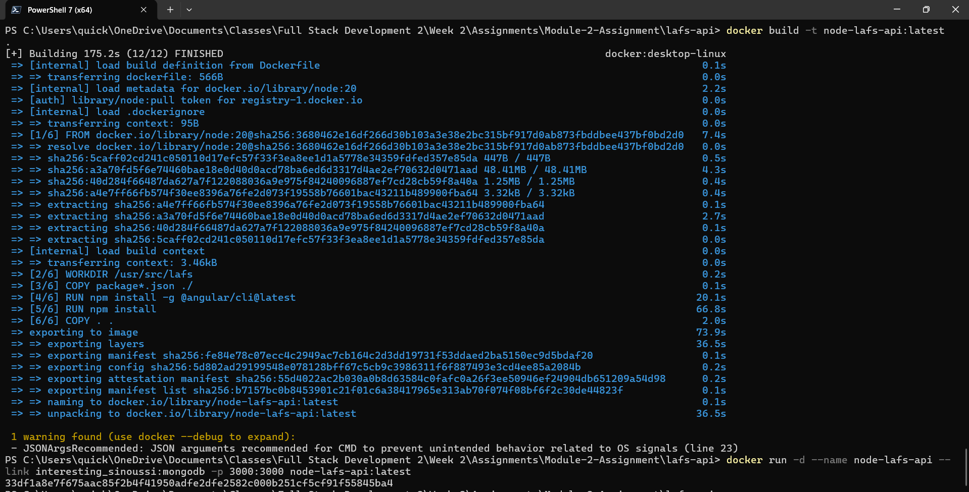
Docker Build lafs-web
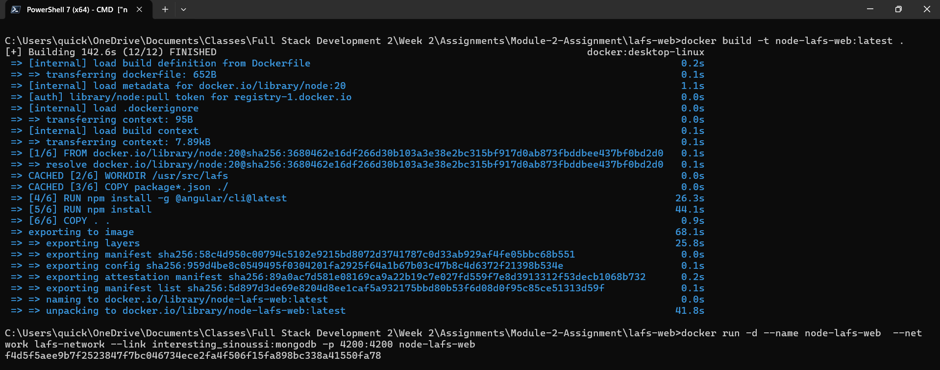

Docker Compose-Up lafs-api 1
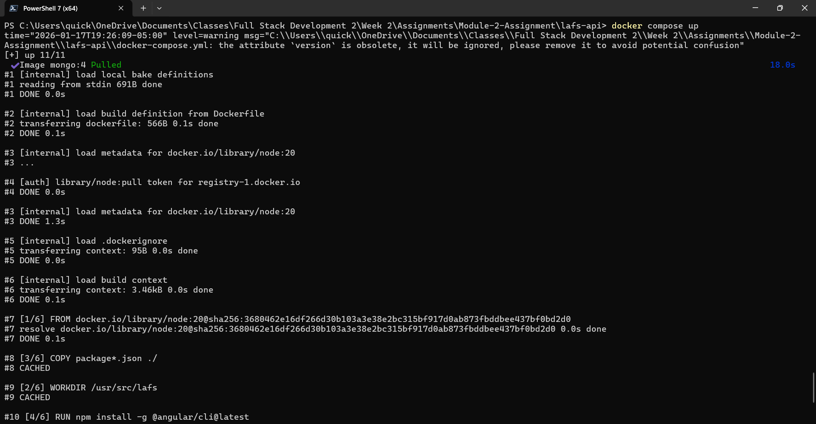

Docker Compose-Up lafs-api 2
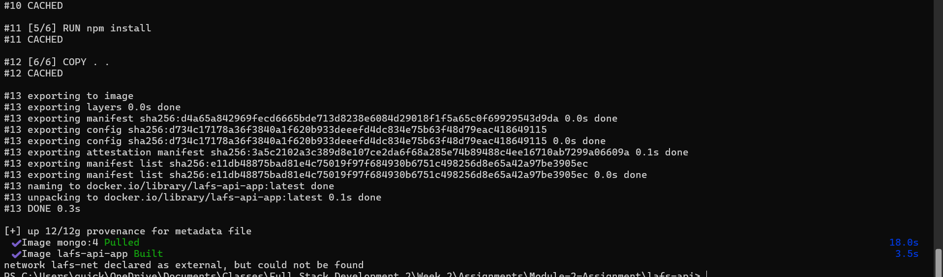
Docker Compose-Up lafs-web 1
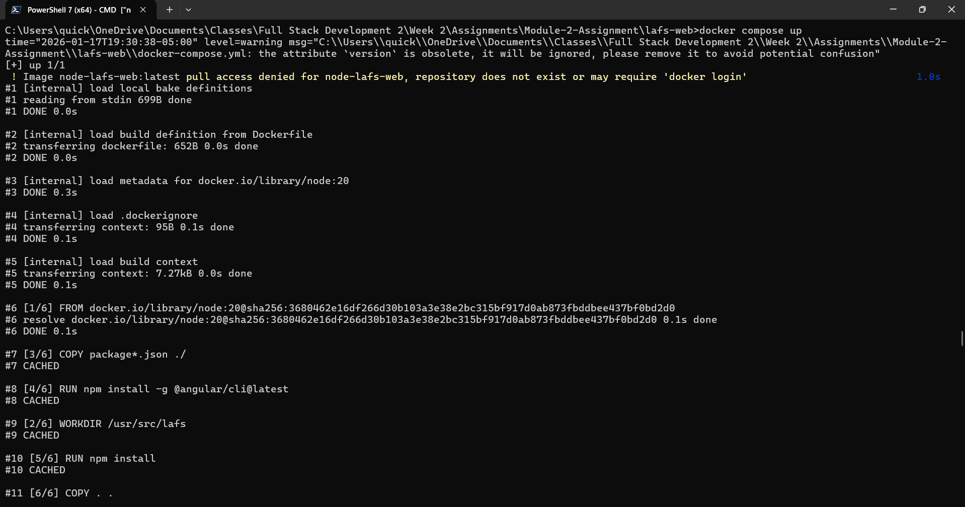
Docker Compose-Up lafs-web 2
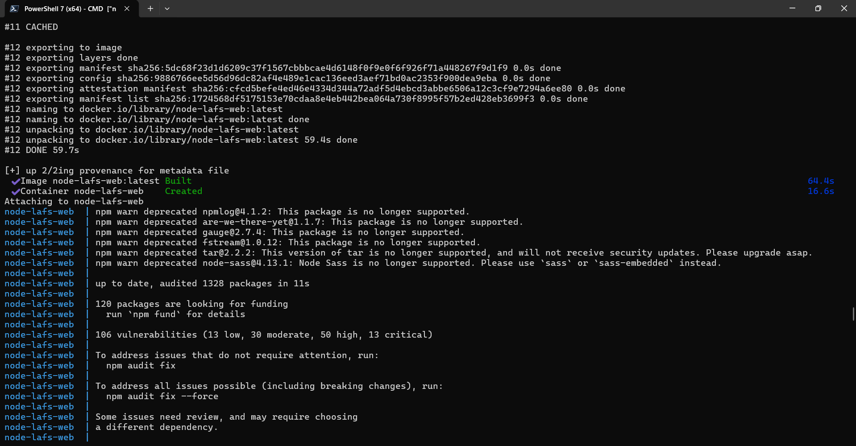

Docker Compose-Up lafs-web 3
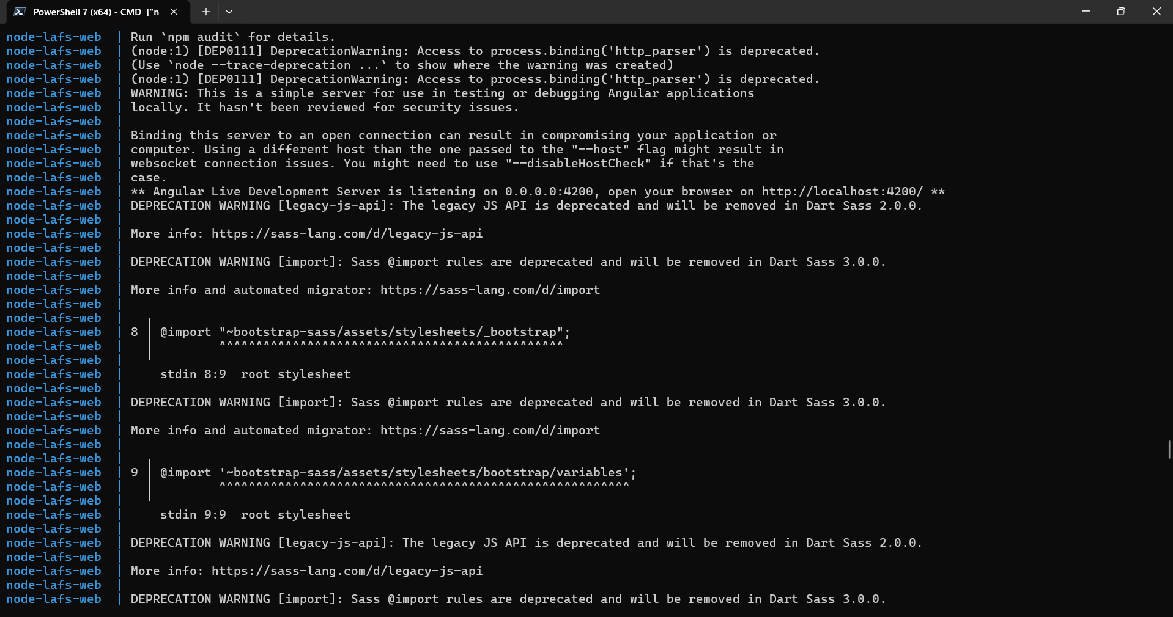

Docker Compose-Up lafs-web 4
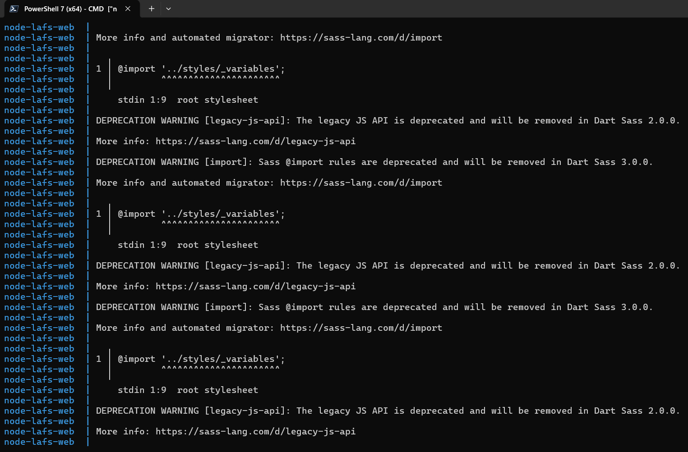
Docker Compose-Up lafs-web 5
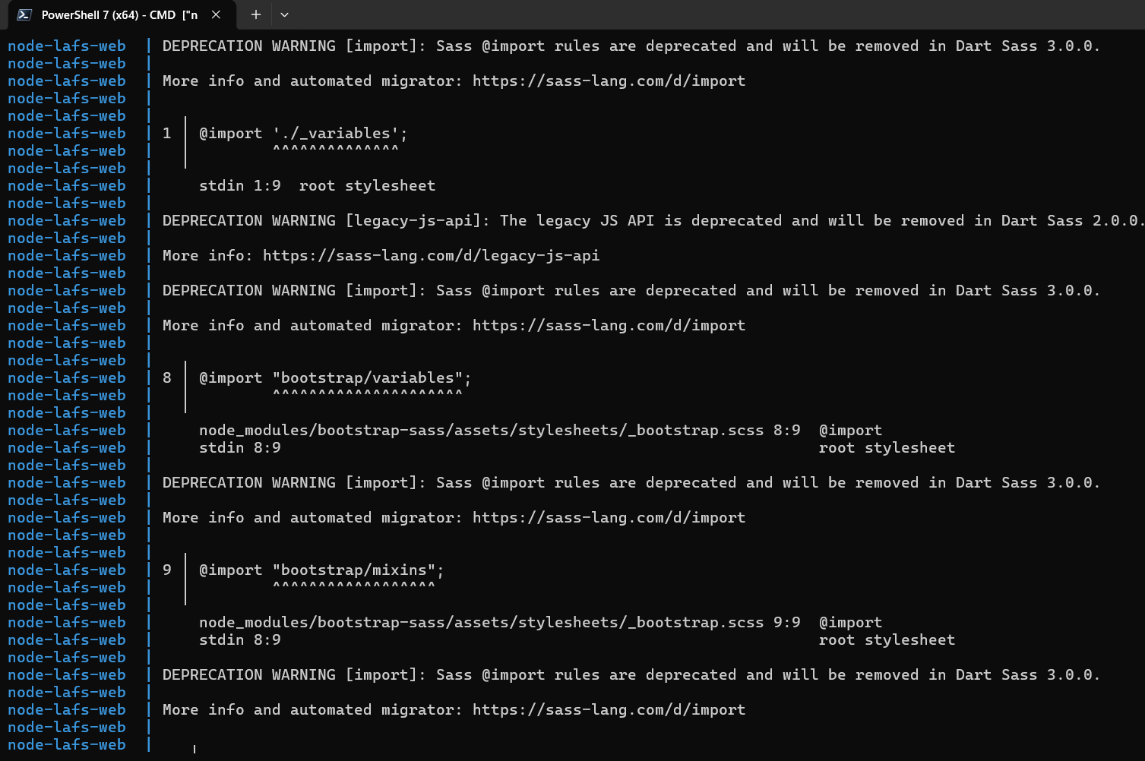

Docker Compose-Up lafs-web 6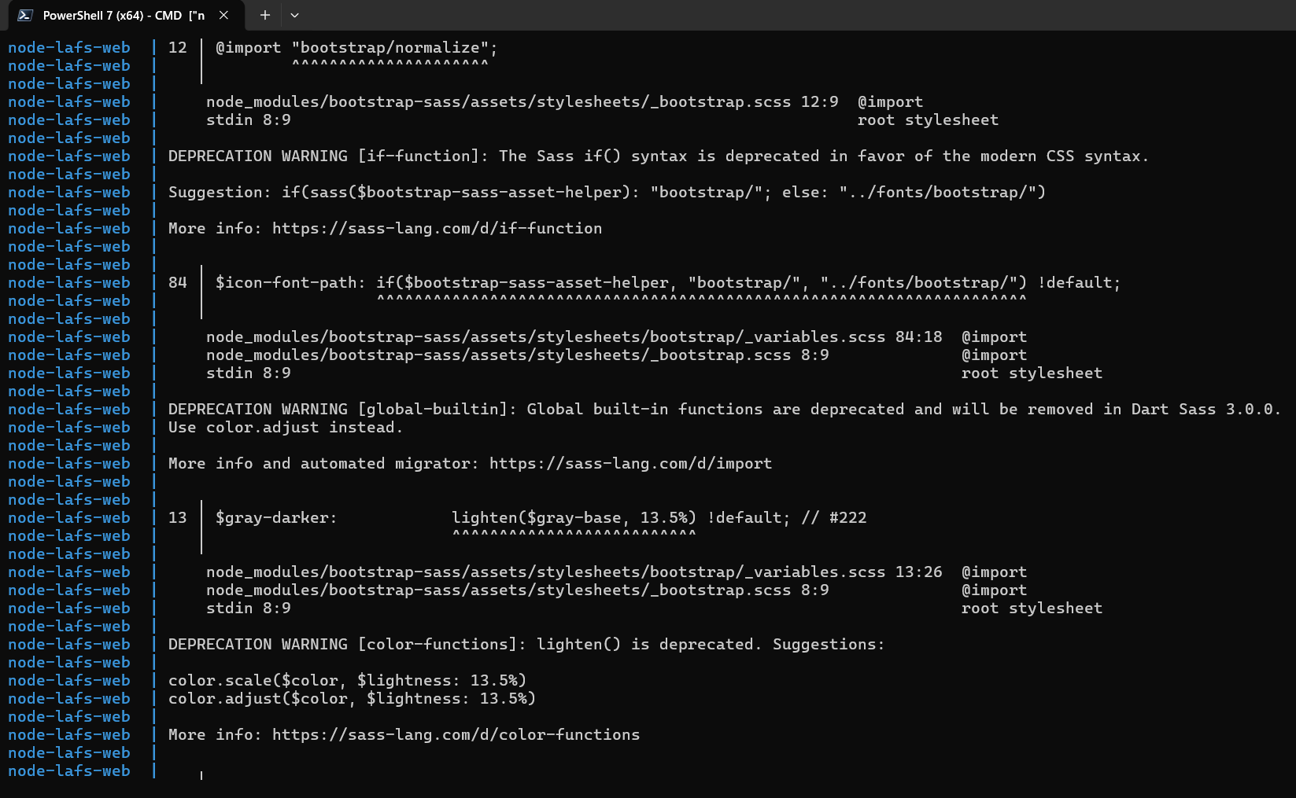
Docker Compose-Up lafs-web 7
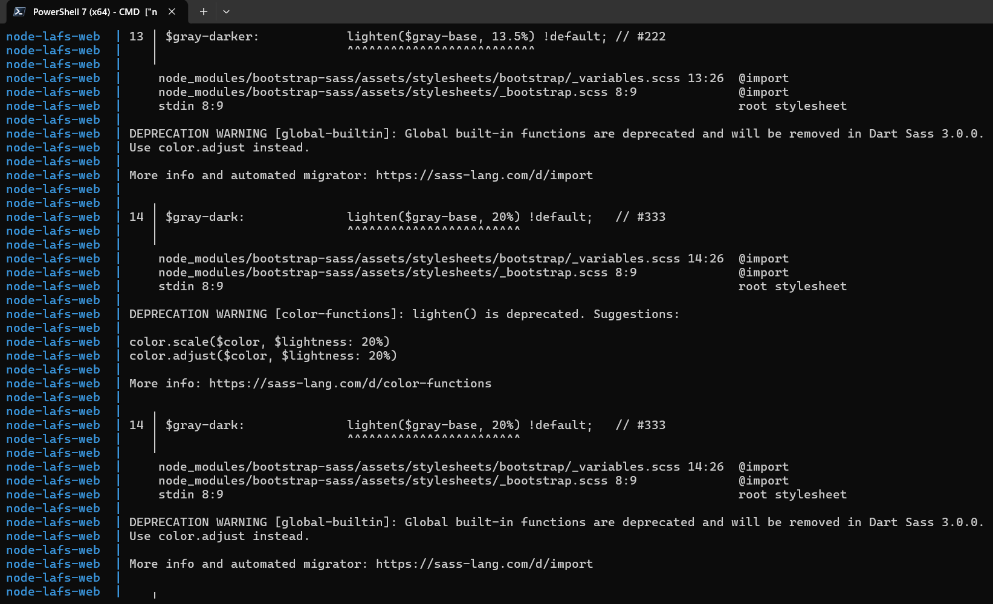
Docker Compose-Up lafs-web 8
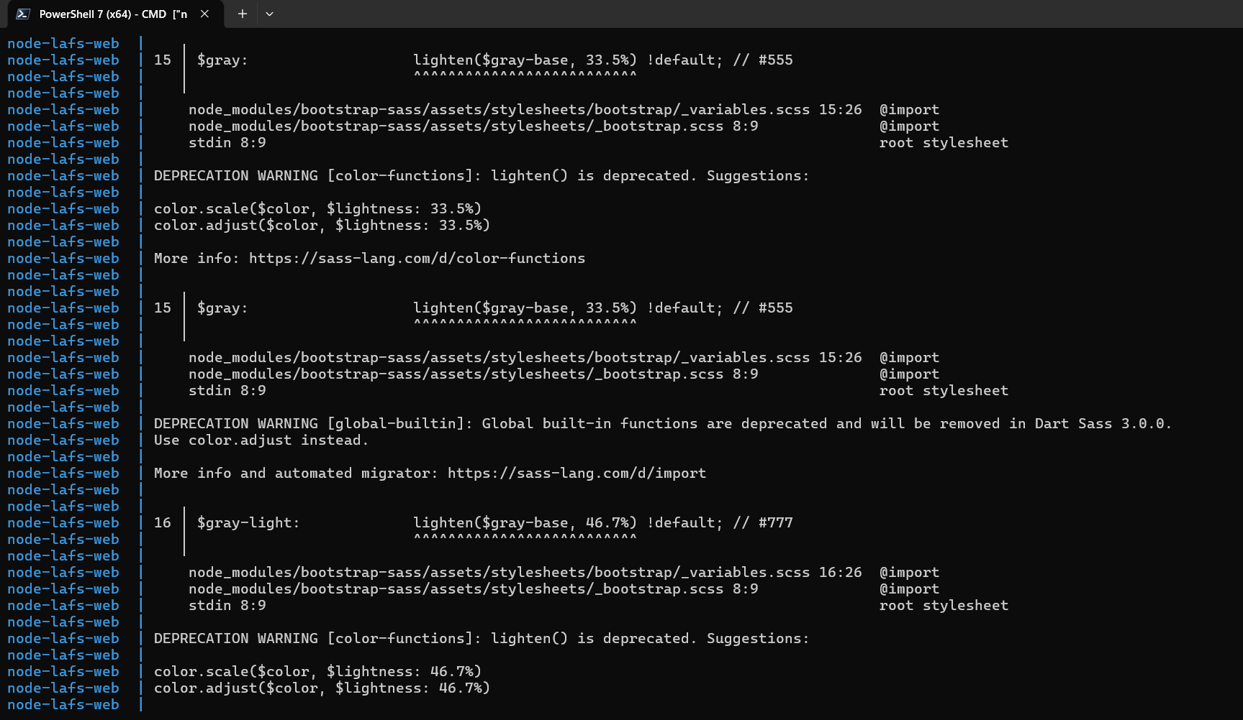
Docker Compose-Up lafs-web 9
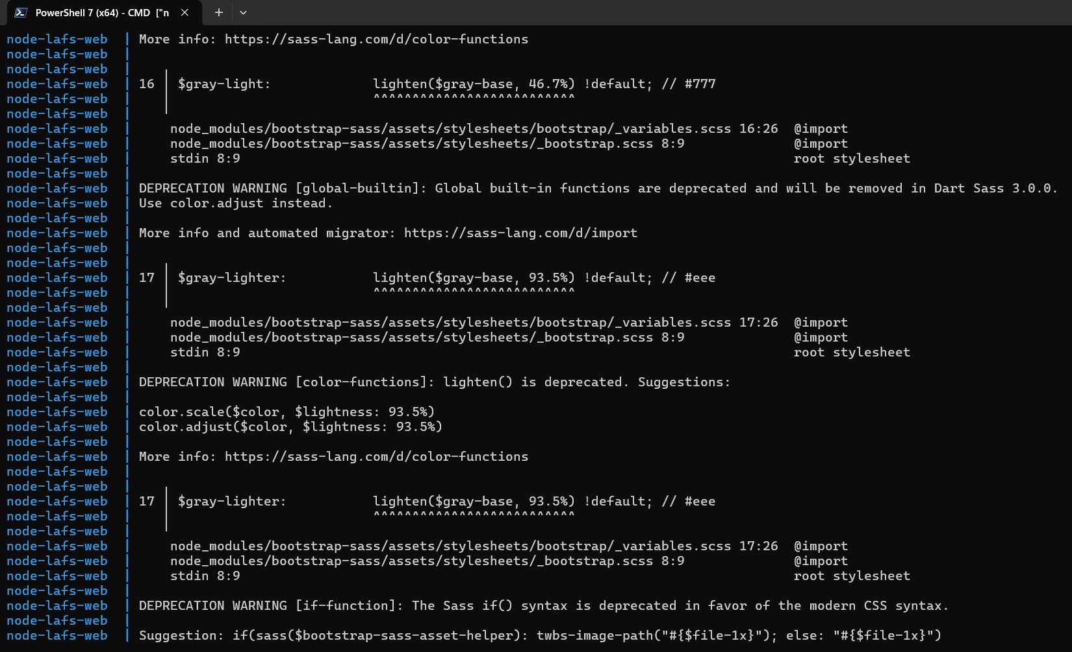

Docker Compose-Up lafs-web 10
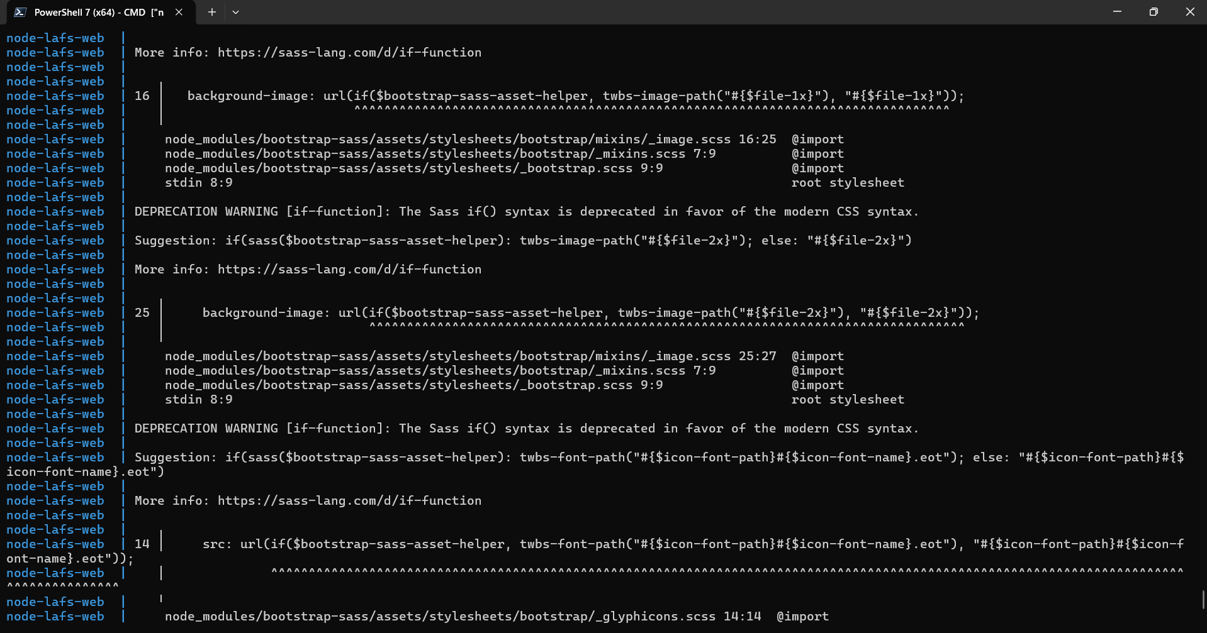
Docker Compose-Up lafs-web 11
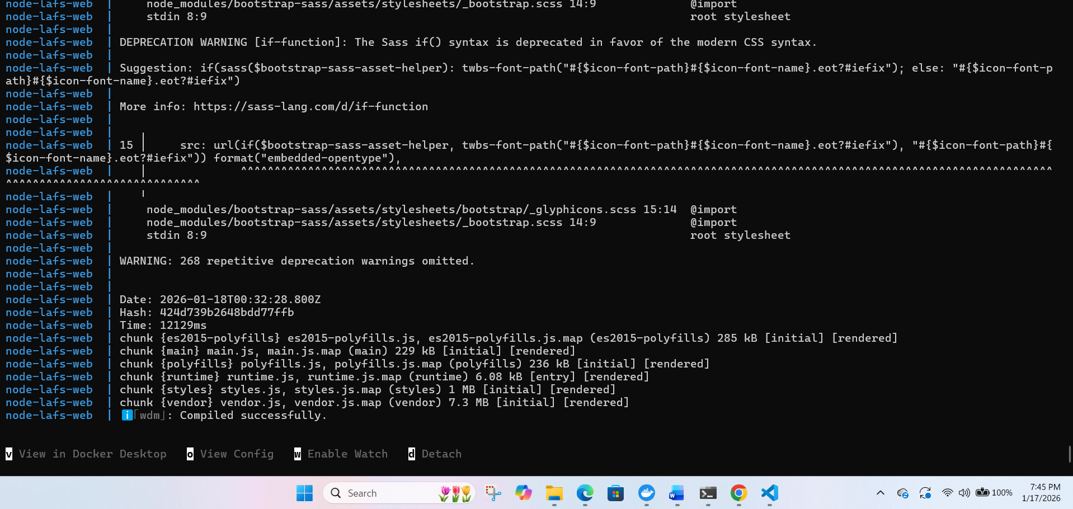
Docker Desktop Images
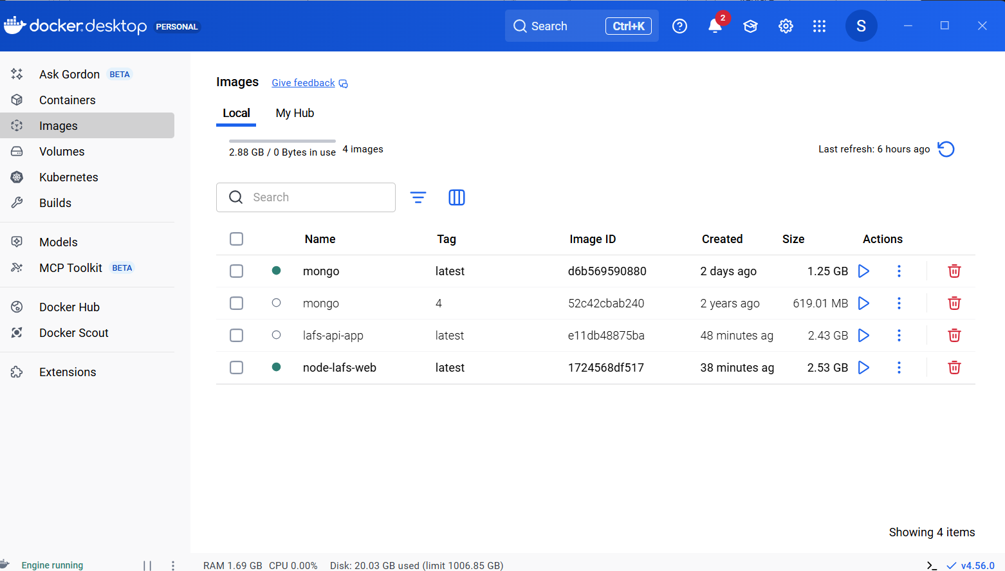
Docker Desktop Containers
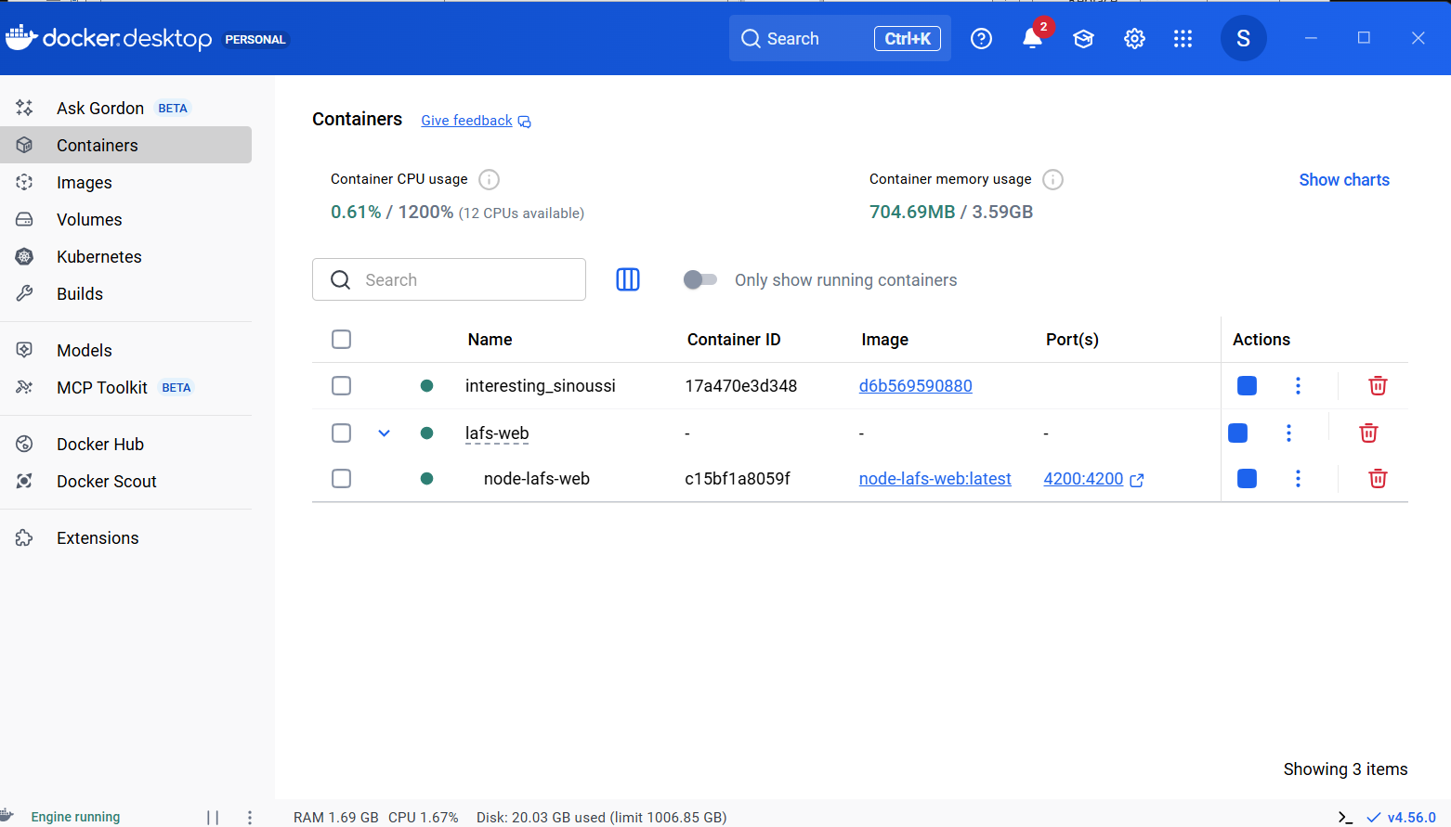

LAFS-API URL
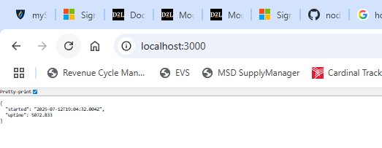
LAFS-WEB URL
